WEBIde Setup

Connect to Your cisco VPN.

Login with your mail id.

Once login was Successful.

We need to add your destination file by following steps.

Go to **sap-webide** folder in your system 🡪 **eclipse** 🡪 **config_master** 🡪

**Service.destinations** 🡪 **destinations**

In the destinations folder we need to add our destination file.

Destination file details are given below.

**#Password=<< Existing password/certificate removed on export >>**

**#**

**#Tue Dec 21 11:40:18 UTC 2021**

**Description=WFP_GWD1**

**Type=HTTP**

**HTML5.PreserveHostHeader=true**

**HTML5.Timeout=60000**

**HTML5.DynamicDestination=true**

**Authentication=BasicAuthentication**

**WebIDEUsage=odata_abap,dev_abap,ui5_execute_abap,odata_gen**

**Name=WFP_GWD1**

**WebIDEEnabled=true**

**ProxyType=OnPremise**

**URL=https://gwd.wingsii.wfp.org:8001**

**sap-client=100**

**WebIDESystem=GWD**

Create a sample App in WEB ide.

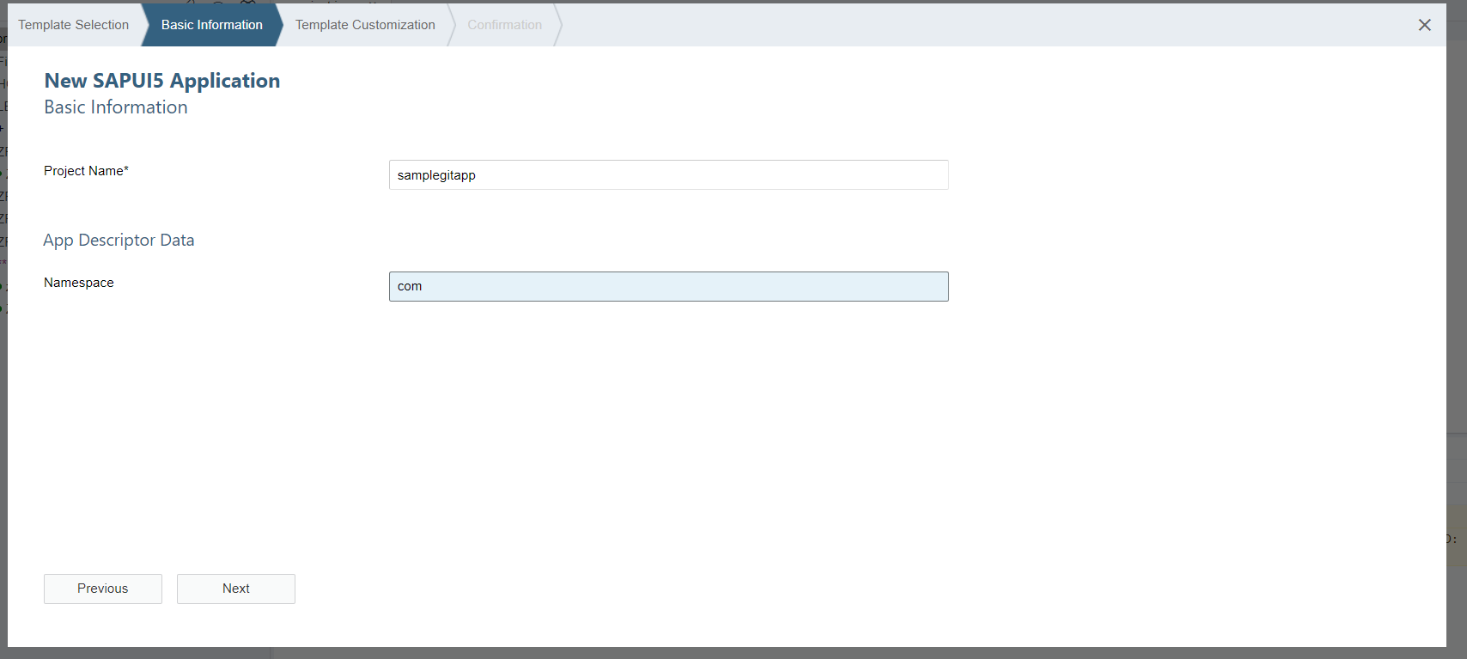

Push the App to Git.

Provide the URL.

Then it prompt for the Authentication for GIT Username and Password.

Click on the merge icon to merge the code into activate branch.

Select the remote branch

Check the stage all Check Box and give the Description and click on the commit and push button.

Select the Remote branches and click on Ok Button

Then provide the GIT Authentication User Name and Password.

Then it push request successfully completed.

In the GIT we can see the Application.

Clone the App from GIT Hub

Provide the GIT URL and click on clone.

Clone has been successfully completed.

Push the Changes to the GIT Hub after cloning.

Here we have did some changes in the View.

Select the stage all check box and commit the changes and click on commit and push.

Provide the GIT User Name and Password.

Then Push request successfully completed.

Here we can see the changes in the code in GIT.

